

# 

COMPLAINT : 144

DATE: 13/Mar/2021

The Manager,

BANK AL-HABIB

TTT,LHR ZONE

Subject: Quotation of Repair and Maintenance. FOR APPROVAL

Number of AC: 1

|  |  |  |  |  |
| --- | --- | --- | --- | --- |
| Sr. | Job Description | Qty | Rate | Amount |
|  | ttt | 1 | 78.0 | 78.0 |
|  | ttt | 1 | 78.0 | 78.0 |
|  | ttt | 1 | 78.0 | 78.0 |
|  | Total |  |  | 234.0 |
|  | Tax 16% |  |  | 37.44 |
|  | Conveynce Charges | 2 | 56 | 112 |
|  | Total |  |  | 383.44 |

**Yours truly,**

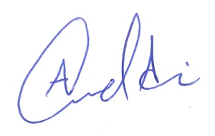 **ECO ENTERPRISES**